5.88: The floor exerts an upward force n on the box, obtained from 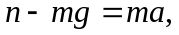 or 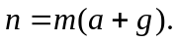 The friction force that needs to be balanced is

